$$React is a front-end framework$$

Is responsible for keeping the front end / user interface up to date with the server

Client side rendering, the rendering is all done in browser/ on page. “Single-page applications” like ebay, facebook. Although apparently some server side rendering trends are returning

Front-end web applications are all about handling data, and displaying data in a user interface.   
  
User interface needs to stay in sync with data, which isn’t easy, especially when dealing with large amounts of data. Keping uI and data in sync would be virtually impossible with just vanilla Javascript for some websites such as AirBnb.

Single page applications with vanilla javascript requires a lot od direct DOM manipulation and traversing and will most likely be spaghetti code. Data (state) is usually stored in the DOM, shared across entire app, which is hard to reason, and can introduce many bugs.

Why do front end web framework exist?   
Because keeping a user interface in sync with data is really hard and a lot of work.   
Front-end frameworks solve this problem and take hard work away from developers.

They basically enforce a correct way of structuring and writing code, avoiding spaghetti code.

Frameworks give developers a consistent way of building web applications.

$$What is react?$$ A JavaScript library for building user interfaces 😐

Extremely popular, declarative, component-based, state-drive JavaScript library for building user interfaces

Created by Facebook

**Component based design**

Components are the building blocks of user interfaces in React

All react does is to take components and draw them on a webpage.

**Declarative**

So in order to describe what each component looks like, we used declarative syntax called JSX. This is telling React what a component should look like, based on current data/ state.

React is abstraction away from the DOM. We never touch the DOM

JSX is a syntax that combines HTML, CSS and JavaScript as well as referencing other components

**State Driven**The main goal of react is to always keep the UI in sync with data.  
Data = State

Whenever the state changes, we manually update the state in our app, and React will then automatically re-render the user interface to reflect the latest state.  
It “reacts” to state changes

It’s not actually a framework, it’s a library, because React is on the “view” layer. We need to pick multiple external libraries to build a complete application.

There are frameworks built on React, such as Next.Js and Remix.

React is extremely popular

**Summary**

React is good at two things:

* Rendering Components on a webpage (UI) based on their current state
* Keeping the UI in sync with state, by re-rendering (reacting) when state changes

$$Setting up a new react project$$

Two options for setting up a react projects

* **Create-React-App**Complete “starter kit” for React applications  
  Everything is already configured (like ESLint, Prettier, Jest etc.)  
  Uses slow and outdated technologies  
  Good for tutorials and learning, but   
  Do not use for real-world apps
* **Vite**Modern build tool that contains a template for setting up React applicationsNeed to manually set up ESLint and other tools  
  Can be a bugger to set up to play nice with ESLint  
  Extremely fast to reload page when code changes (Hot module replacement)  
  Bundling is also fast  
  Perfect choice for using with modern real-world apps

The react team now advises to use a “React Framework” for new projects, such as NextJs or Remix. A React framework contains solutions for things like routing, data fetching and server side rendering. Things react does not provide easily out of the box.

A React Framework is a framework built on top of the React library, makes it easier to build applications than with vanilla react alone. A React Framework is not always necessary or the best idea. Vanilla React apps, still have a very important place too.

$$Components as Building Blocks$$

React applications are entirely made out of components

Building blocks of user interfaces in React

Pieces of UI that has its own data, javascript logic, and appearance (how it works and looks)

Each component is like a separate view.

We build complex UIs by building multiple components and combining them

Components can be reused, nested inside each other, and pass data between.

Whenever we need duplication in UI, we create new component and use it as many times as necessary.

$$What is JSX? \\ JSX is a declarative syntax that we use to describe what components look like and how they work. \\ Components must return a block of JSX, which React will then use to render component on the UI$$

JSX looks like HTML but is actually an extension of JavaScript, that allows us to embed JavaScript, CSS and React components into HTML.  
Each JSX element is converted to a React.createElement function call

We could use React without JSX – manually write create Elements, but why would you?

Imperative –

like building a website with just JS, imperative involves manual DOM element selections and DOM traversing.  
Step by Step DOM mutations until we reach desired UI

Declarative –

Simply describe what the UI should look like at all times always based on the current data in the component. (Props and State)

Abstract away from the DOM : Never touch the DOM  
We think of the UI as a reflection of the current data

Separation of Concerns

Before single page apps, we used to have one file per technology (JS , HTML , CSS)  
This was the traditional separation of concerns  
  
As pages got more interactive and became single page applications, where the JavaScript started to determine the UI and the content in general.   
JavaScript is in charge of HTML.  
If JavaScript is in charge of HTML and the HTML alone makes little sense, why not bring them together? Hence React Components + JSX.

React does have separation of concerns, where it is one concern per component

$$Props, Immutability and One Way Data Flows$$**Props**  
Props are used to pass data from parent components to child components (down the component tree)  
Essential tool to configure and customise components like function parameters.

With props, parent components control how child components look and work

Anything can be passed as props: single values, arrays, objects, functions event other components  
  
  
**Immutability**  
React renders a component based on its current data. The UI will always be kept in sync with that data. The data is made out of props and state.  
State is basically internal components that can be updated by the components logic, whereas props is parent data that is coming from parent component. This data cannot be modified by child component. Props are immutable, they are read-only.

If you need to mutate props, you actually need state.  
  
This is because mutating props would affect parent, and create side effects because that’s just how objects work in JavaScript.

React is about pure functions (functions without side effects)   
Components have to be pure functions in terms of props and state.   
This allows React to optimise apps, avoid bugs and make apps predictable.  
  
**One way data flow**  
Angular apparently has a 2 way data flow. But React uses a one-way data flow.   
It makes app way more predictable and easier to understand, and debug.  
  
Two-way data binding is less performant to implement.

$$The Rules of JSX$$

General Rules of JSX

* JSX works like HTML, but we can enter JavaScript mode by using {} for text or attribute
* We can place JavaScript expressions inside{}. Examples: references variables, create arrays of objects, [].map ternary
* Statements are not allowed (if/else for switch
* JSX produces a JavaScript expressions
* We can place other pieces of JSX inside  
  we can write JSX anywhere inside a component( in if else, assign to variables, pass to functions)
* A piece of JSX can only have one root element. If you need more, use <React.Fragment>

Differences between JSX and HTML

* className instead of HTML class
* htmlFor instead of HTML’s for
* Every tag needs to be closed. Examples <img /> or <br />
* All event handlers and other properties need to be camelCased.
* Exception: aria-* and data-* are written with dashes like in HTML
* CSS inline stytles are written like tis {{<style>}} (to reference a variable, and then an object
* CSS property names are also camelCased
* Comments need to be in {} (because they are JS)

$$State$$

Data os coming from outside the component

What if a component needs to hold data over time?

What if we want an interactive app?  
  
STATE!

State is data that a component can hold over time, necessary for information that it needs to remember throughout the app’s life cycle

“Components Memory”

It can be notifications, a shopping cart, search bar etc.   
These components need to hold data over time, so they are all pieces of state.

Updating component state triggers React to re-render the component

When one single component is rendered, we call that a view

All the views combined together make up the final User interface.

$$The Mechanics of State \\ Because React is declarative, we do not do direct DOM$$ manipulations. (How many more times is this going to be said?)  
  
In React, a view is updated by re-rendering the component, which is an important React principle

Re-rendering is React calling the component function again, React is removing the entire view and replacing it with a new one, each time a re-render is required to happen.  
  
React preserves the component state during re-render. The State will not be reset unless the component disappears from the UI completely, which we call unmounting.

To update a view, we update the state. React does its namesake and the view is updated by result.

$$UI as a function of State$$

Each component has and manages its own state. No matter how many times we render the same component, allowing it to operate independently from the other instances.

We can basically think of the entire application view as a function of state. A react application is fundamentally about changing state over time, and correctly displaying the state at all times. With State, we now view UI as a reflection of data changing over time.

We describe that reflection of data using state, event handlers and JSX.

Practical guidelines about State:

* Use a state variable for any data that the component should keep track of ( i.e. “remember”) over time. This is data that will change at some point. In Vanilla JS, that’s a let variable, or an [] or {}.
* Whenever you want something in the component to be dynamic, create a piece of state related to that “thing”, and update the state when the “thing” should change (aka “be dynamic”)
  + Example: A modal window can be open or closed. So, we create a state variable “isOpen” that tracks whether the modal is open or not. On isOpen = true, we display the window. On isOpen = false, we hide the window.
* If you want to change the way a component looks, or the data it displays, update its state. This usually happens in an event handler function
* When building a component, imagine its view as a reflection of state changing over time.
* For data that should not trigger component re-renders, don’t use state. Use a regular variable instead. This is a common beginner pitfall.

$$State vs Props$$

What’s the difference between State and Props

State is internal data – data that is owned by the component in which it is declared

Props is external data – data that is owned by the parent component, similar to function parameters.  
  
Parents can pass data into children

State data can be saw like Component Memory, and can be updated by the component itself, and this will cause component to re-render. This makes components interactive

Props are read-only, receiving new props causes component to re-render. (Usually when the parent’s state has been updated.)

Whenever a piece of state is passed as a prop, when that state updates, both components are re-rendered.   
  
Props are used to give parent component the ability to configure their child components. Props can be seen as settings in the child components, which the parent component can define as they wish

$$Thinking in React$$

Thinking in React means to have a React Mindset, thinking about the components, state, data flow, effects etc. Thinking about State Transitions, not element mutations.

Thinking in React can be seen as a whole process, to help us build apps in a more structured way.  
  
1. Break the UI into components and establish the component tree.  
2. Built a static version in React (without state and interactivity)

3. Think about state

* When to use state
* Types of state: local vs global
* Where to place each piece of state

4. Establish Data flow

* One-way data flow
* Child-to-parent communication
* Accessing global state

When you know how to think in React, you will be able to answer

* How to break up a UI design into components?
* How to make some components reusable?
* How to assemble UI from reusable components?
* What pieces of state do I need for interactivity?
* Where to place state? (What component should “own” each piece of state)
* What types of state can or should I use?
* How to make data flow through app?

$$Fundamentals of State Management$$

We can use the useState function to create multiple pieces of state, in order to track data that changes over the life cycle of an application.

State Management deciding when to create pieces of state, what types of state are necessary, where to place each piece of state inside our code base, and also how all the data should flow through the app. State management is giving each piece of state a home within our code base.

**Local vs Global State**In React, each piece of state is either local state, or global state

Local State is State needed by one or a few components

* State that is defined in a component and only that component and child components have access to it (by passing via props)
* Example could be input text in a search bar, only that component needs to know about this data (the account sidebar or footer doesn’t require this data etc.)

Global State is state that many components might need

* Shared state that is accessible to every component in the entire application
* Example would include Shopping Cart

One important guideline in state management is to always start with local state, and to only move to global state if you really need it. Similar to data minimisation, where you only request data you need, only allow access to state where it’s required.

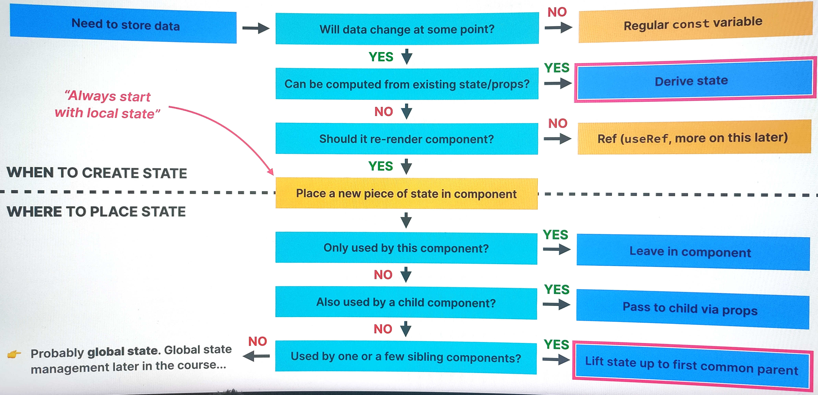

$$Derived State$$

Derived State is state that is computed from an existing piece of state or from props.

For example. Const cart could contain ([

{ name: “JavaScript course”, price : “15.99”},

{ name: “Node.js Bootcamp course”, price : “14.99” }

])

We could create derived states from the totalItems, or totalPrice, which would be dynamic as they’re always reflecting the current values from cart.   
  
Derived states are stored in regular variables, no useState.

The cart state is the single source of truth for the related data.

This works because re-rendering component will automatically re-calculate derived state.

These latter two variables need to stay in sync with **cart**, and to have them as static variables would require 2 additional state updates, and 2 additional re-renders.

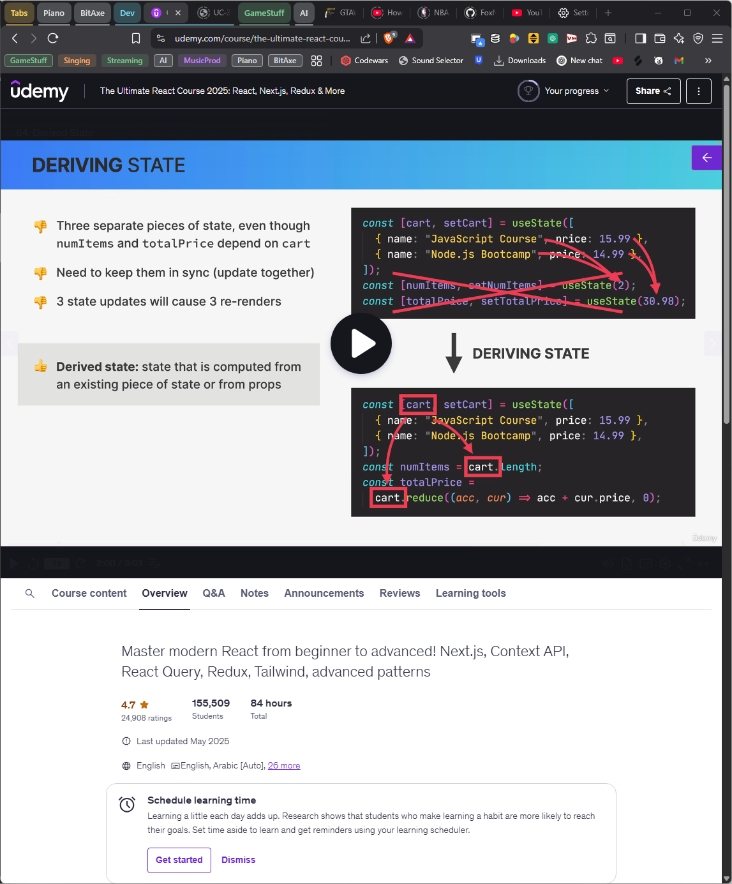

$$Children Prop$$

The children prop is an empty “hole” that can be filled by any JSX the component receives as children.  
  
We pass this by instead of immediately closing the element, we can add some JSX into the element (writing any HTML markup) and we can call this in a component with {children}, like a function argument.

By defining child elements like this, we are passing them into the component just like we pass any other prop. The children prop is really an ideal way of making reusable and configurable components.  
  
